Analyzing the Impact of Car Features on Price and Profitability

**PROJECT DESCRIPTION:**

* The automotive industry has been rapidly evolving over the past few decades, with a growing focus on fuel efficiency, environmental sustainability, and technological innovation. At the same time, traditional gasoline-powered cars remain dominant in the market, with varying fuel types and grades available to consumers.
* For the given dataset, as a Data Analyst, the client has asked How can a car manufacturer optimize pricing and product development decisions to maximize profitability while meeting consumer demand?
* This problem could be approached by analysing the relationship between a car's features, market category, and pricing, and identifying which features and categories are most popular among consumers and most profitable for the manufacturer.
* By using data analysis techniques such as regression analysis and market segmentation, the manufacturer could develop a pricing strategy that balances consumer demand with profitability, and identify which product features to focus on in future product development efforts
* The dataset contains information on various car models and their specifications, and is titled "Car Features and MSRP". It was collected and made available on Kaggle by Cooper Union; a private college located in New York City.
* **Number of observations:** 11,915
* **Number of variables:** 16
* **File type:** CSV (Comma Separated Values)

**APPROACH:**

* To perform the project a systematic approach was followed. A dataset was downloaded. Microsoft Excel 2021 was selected as the primary tool for data analysis such as cleaning, deleting blank rows and due to its versatility and robust capabilities in handling tabular data. Specific techniques such as pivot tables, charts, visualizations and were employed to analyze the dataset and extract meaningful insights.

**TECH-STACK USED:**

* Software: Microsoft Excel 2021
* Purpose: Excel was chosen for its extensive data analysis functions, including pivot tables, charts, and statistical functions and visualization of the Car data

INSIGHTS: various key insights were uncovered through the data analytics process. Meaningful trends and visualization patterns were observed in the data

# 

**TASK ANALYSIS:**

**Insight Required:** How does the popularity of a car model vary across different market categories?

* **Task 1.A:** Create a pivot table that shows the number of car models in each market category and their corresponding popularity scores.
* **Task 1.B:** Create a combo chart that visualizes the relationship between market category and popularity.

|  |  |  |
| --- | --- | --- |
| **MARKET CATEGORY** | **Average of Popularity** | **Count of Model** |
| **Crossover** | **1529.03** | **1103** |
| **Crossover,Diesel** | **873.00** | **7** |
| **Crossover,Exotic,Luxury,High-Performance** | **238.00** | **1** |
| **Crossover,Exotic,Luxury,Performance** | **238.00** | **1** |
| **Crossover,Factory Tuner,Luxury,High-Performance** | **1823.46** | **26** |
| **Crossover,Factory Tuner,Luxury,Performance** | **2607.40** | **5** |
| **Crossover,Factory Tuner,Performance** | **210.00** | **4** |
| **Crossover,Flex Fuel** | **2073.75** | **64** |
| **Crossover,Flex Fuel,Luxury** | **1173.20** | **10** |
| **Crossover,Flex Fuel,Luxury,Performance** | **1624.00** | **6** |
| **Crossover,Flex Fuel,Performance** | **5657.00** | **6** |
| **Crossover,Hatchback** | **1675.69** | **72** |
| **Crossover,Hatchback,Factory Tuner,Performance** | **2009.00** | **6** |
| **Crossover,Hatchback,Luxury** | **204.00** | **7** |
| **Crossover,Hatchback,Performance** | **2009.00** | **6** |
| **Crossover,Hybrid** | **2563.38** | **42** |
| **Crossover,Luxury** | **884.55** | **410** |
| **Crossover,Luxury,Diesel** | **2195.85** | **33** |
| **Crossover,Luxury,High-Performance** | **1037.22** | **9** |
| **Crossover,Luxury,Hybrid** | **630.92** | **24** |
| **Crossover,Luxury,Performance** | **1344.85** | **113** |
| **Crossover,Luxury,Performance,Hybrid** | **3916.00** | **2** |
| **Crossover,Performance** | **2585.96** | **69** |
| **Diesel** | **1730.90** | **84** |
| **Diesel,Luxury** | **2275.00** | **51** |
| **Exotic,Factory Tuner,High-Performance** | **1046.38** | **21** |
| **Exotic,Factory Tuner,Luxury,High-Performance** | **517.54** | **52** |
| **Exotic,Factory Tuner,Luxury,Performance** | **520.00** | **3** |
| **Exotic,Flex Fuel,Factory Tuner,Luxury,High-Performance** | **520.00** | **13** |
| **Exotic,Flex Fuel,Luxury,High-Performance** | **520.00** | **11** |
| **Exotic,High-Performance** | **1261.57** | **252** |
| **Exotic,Luxury** | **112.67** | **12** |
| **Exotic,Luxury,High-Performance** | **467.08** | **79** |
| **Exotic,Luxury,High-Performance,Hybrid** | **204.00** | **1** |
| **Exotic,Luxury,Performance** | **217.03** | **36** |
| **Factory Tuner,High-Performance** | **1941.42** | **106** |
| **Factory Tuner,Luxury** | **617.00** | **2** |
| **Factory Tuner,Luxury,High-Performance** | **2133.37** | **215** |
| **Factory Tuner,Luxury,Performance** | **1413.42** | **31** |
| **Factory Tuner,Performance** | **1733.10** | **89** |
| **Flex Fuel** | **2217.30** | **872** |
| **Flex Fuel,Diesel** | **5657.00** | **16** |
| **Flex Fuel,Factory Tuner,Luxury,High-Performance** | **258.00** | **1** |
| **Flex Fuel,Hybrid** | **155.00** | **2** |
| **Flex Fuel,Luxury** | **746.54** | **39** |
| **Flex Fuel,Luxury,High-Performance** | **878.91** | **33** |
| **Flex Fuel,Luxury,Performance** | **1380.07** | **28** |
| **Flex Fuel,Performance** | **1702.36** | **81** |
| **Flex Fuel,Performance,Hybrid** | **155.00** | **2** |
| **Hatchback** | **1293.00** | **614** |
| **Hatchback,Diesel** | **873.00** | **14** |
| **Hatchback,Factory Tuner,High-Performance** | **1205.15** | **13** |
| **Hatchback,Factory Tuner,Luxury,Performance** | **886.89** | **9** |
| **Hatchback,Factory Tuner,Performance** | **2159.05** | **22** |
| **Hatchback,Flex Fuel** | **5657.00** | **7** |
| **Hatchback,Hybrid** | **2121.25** | **72** |
| **Hatchback,Luxury** | **1379.50** | **46** |
| **Hatchback,Luxury,Hybrid** | **454.00** | **3** |
| **Hatchback,Luxury,Performance** | **1566.13** | **38** |
| **Hatchback,Performance** | **1039.65** | **252** |
| **High-Performance** | **1821.45** | **199** |
| **Hybrid** | **2105.57** | **123** |
| **Luxury** | **1107.55** | **851** |
| **Luxury,High-Performance** | **1668.02** | **334** |
| **Luxury,High-Performance,Hybrid** | **568.83** | **12** |
| **Luxury,Hybrid** | **724.69** | **48** |
| **Luxury,Performance** | **1292.62** | **673** |
| **Luxury,Performance,Hybrid** | **2333.18** | **11** |
| **Performance** | **1371.08** | **584** |
| **Performance,Hybrid** | **155.00** | **1** |
| **Grand Total** | **1499.397823** | **8084** |

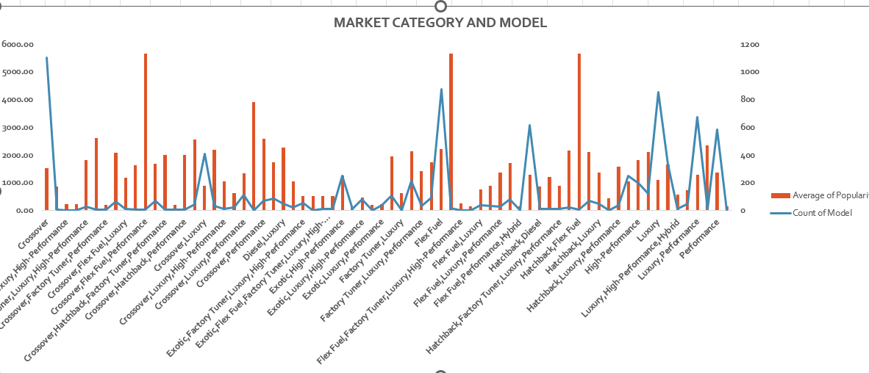

**Insight Required:** What is the relationship between a car's engine power and its price?

* **Task 2:** Create a scatter chart that plots engine power on the x-axis and price on the y-axis. Add a trendline to the chart to visualize the relationship between these variables.

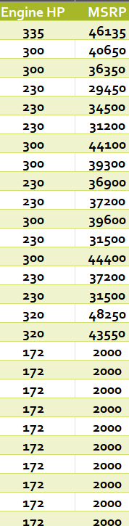

**Insight Required:** Which car features are most important in determining a car's price?

* **Task 3:** Use regression analysis to identify the variables that have the strongest relationship with a car's price. Then create a bar chart that shows the coefficient values for each variable to visualize their relative importance.

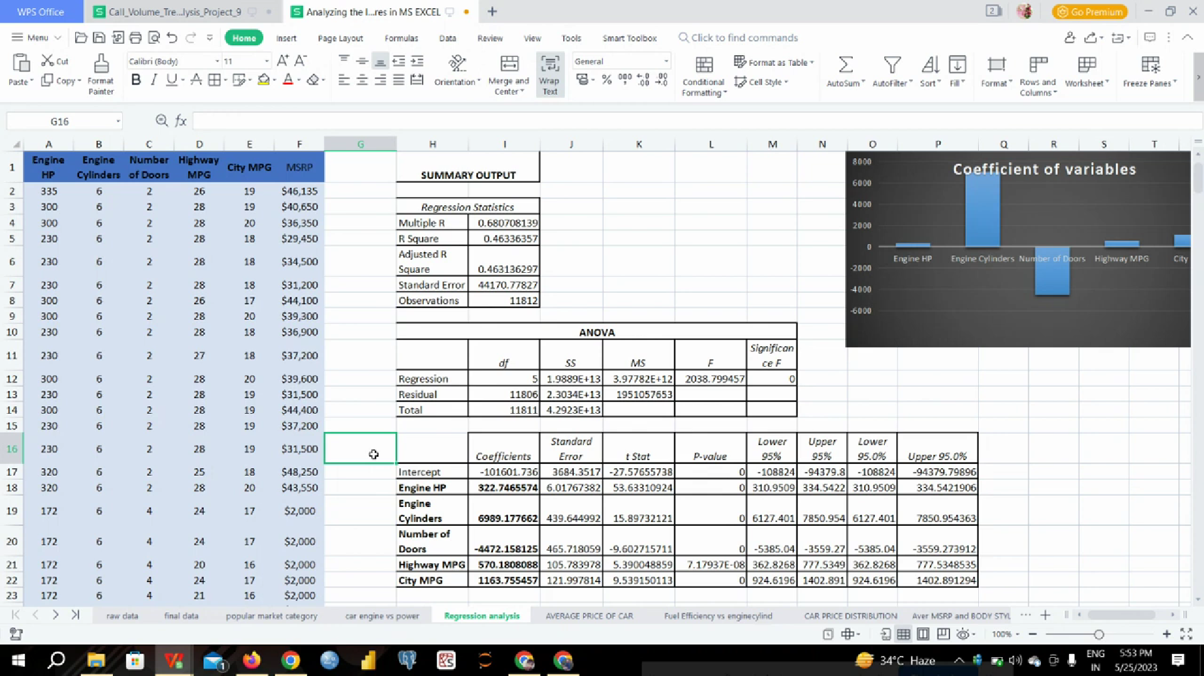

**Insight Required:** How does the average price of a car vary across different manufacturers?

* **Task 4.A:** Create a pivot table that shows the average price of cars for each manufacturer.
* **Task 4.B:** Create a bar chart or a horizontal stacked bar chart that visualizes the relationship between manufacturer and average price.

|  |  |
| --- | --- |
| **Row Labels** | **Average of MSRP** |
| **Acura** | **34887.59** |
| **Alfa Romeo** | **61600.00** |
| **Aston Martin** | **197910.38** |
| **Audi** | **53452.11** |
| **Bentley** | **247169.32** |
| **BMW** | **61546.76** |
| **Bugatti** | **1757223.67** |
| **Buick** | **28206.61** |
| **Cadillac** | **56231.32** |
| **Chevrolet** | **28273.36** |
| **Chrysler** | **26722.96** |
| **Dodge** | **22390.06** |
| **Ferrari** | **237383.82** |
| **FIAT** | **22206.02** |
| **Ford** | **27393.42** |
| **Genesis** | **46616.67** |
| **GMC** | **30493.30** |
| **Honda** | **26629.82** |
| **HUMMER** | **36464.41** |
| **Hyundai** | **24597.04** |
| **Infiniti** | **42394.21** |
| **Kia** | **25112.39** |
| **Lamborghini** | **331567.31** |
| **Land Rover** | **67823.22** |
| **Lexus** | **47549.07** |
| **Lincoln** | **42494.37** |
| **Lotus** | **69188.28** |
| **Maserati** | **114207.71** |
| **Maybach** | **546221.88** |
| **Mazda** | **19719.06** |
| **McLaren** | **239805.00** |
| **Mercedes-Benz** | **71537.81** |
| **Mitsubishi** | **21215.47** |
| **Nissan** | **28513.37** |
| **Oldsmobile** | **11542.54** |
| **Plymouth** | **3122.90** |
| **Pontiac** | **19321.55** |
| **Porsche** | **101622.40** |
| **Rolls-Royce** | **351130.65** |
| **Saab** | **27413.50** |
| **Scion** | **19932.50** |
| **Spyker** | **213323.33** |
| **Subaru** | **24827.50** |
| **Suzuki** | **17900.96** |
| **Toyota** | **28946.15** |
| **Volkswagen** | **28076.20** |
| **Volvo** | **28541.16** |
| **Grand Total** | **40559.94** |

**Insight Required:** What is the relationship between fuel efficiency and the number of cylinders in a car's engine?

* **Task 5.A:** Create a scatter plot with the number of cylinders on the x-axis and highway MPG on the y-axis. Then create a trendline on the scatter plot to visually estimate the slope of the relationship and assess its significance.
* **Task 5.B:** Calculate the correlation coefficient between the number of cylinders and highway MPG to quantify the strength and direction of the relationship.

|  |  |
| --- | --- |
| Engine Cylinders | highway MPG |
| 6 | 26 |
| 6 | 28 |
| 6 | 28 |
| 6 | 28 |
| 6 | 28 |
| 6 | 28 |
| 6 | 26 |
| 6 | 28 |
| 6 | 28 |
| 6 | 27 |
| 6 | 28 |
| 6 | 28 |
| 6 | 28 |
| 6 | 28 |
| 6 | 28 |
| 6 | 25 |
| 6 | 28 |
| 6 | 24 |
| 6 | 24 |
| 6 | 20 |
| 6 | 24 |
| 6 | 21 |
| 6 | 24 |
| 6 | 20 |

|  |  |
| --- | --- |
| CORRELATION COEFFICIENT | |
| **-0.62** | **SHOWING NEGATIVE CORRELATION** |

## **BUILDING THE DASHBOARD**

**Task 1:** How does the distribution of car prices vary by brand and body style?

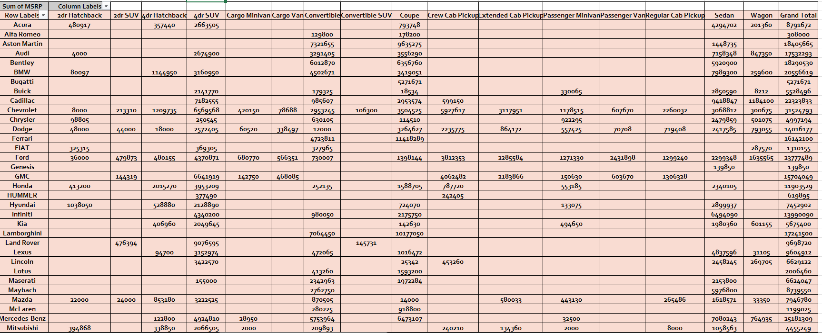

**Task 2:** Which car brands have the highest and lowest average MSRPs, and how does this vary by body style?

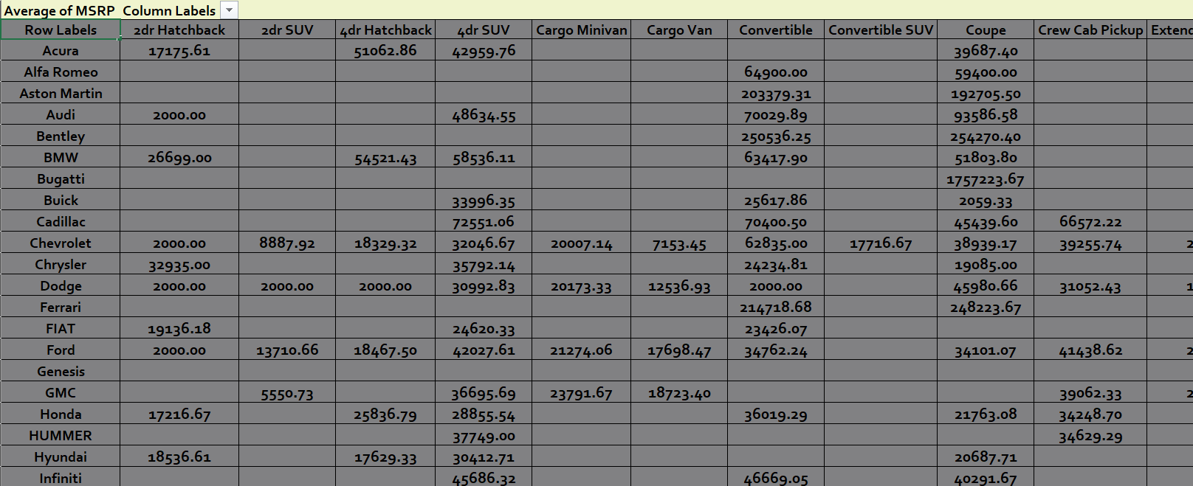

**Task 3:** How do the different feature such as transmission type affect the MSRP, and how does this vary by body style?

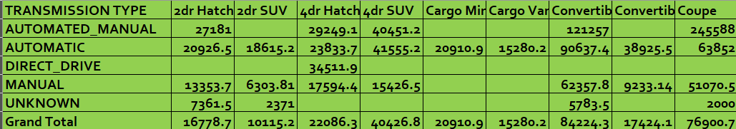

**Task 4:** How does the fuel efficiency of cars vary across different body styles and model years?

|  |  |
| --- | --- |
| **YEAR** | **AVG OF HIGHWAY MPG** |
| **1990** | **23.07** |
| **1991** | **22.15** |
| **1992** | **24.05** |
| **1993** | **24.22** |
| **1994** | **23.87** |
| **1995** | **23.23** |
| **1996** | **23.73** |
| **1997** | **22.31** |
| **1998** | **21.85** |
| **1999** | **22.98** |
| **2000** | **24.04** |
| **2001** | **23.71** |
| **2002** | **22.77** |
| **2003** | **22.74** |
| **2004** | **23.13** |
| **2005** | **23.64** |
| **2006** | **23.42** |
| **2007** | **21.94** |
| **2008** | **22.99** |
| **2009** | **23.89** |
| **2010** | **24.17** |
| **2011** | **25.23** |
| **2012** | **26.35** |
| **2013** | **27.45** |
| **2014** | **26.89** |
| **2015** | **28.51** |
| **2016** | **28.54** |
| **2017** | **28.33** |
| **Grand Total** | **26.32** |

**Task 5:** How does the car's horsepower, MPG, and price vary across different Brands?

|  |  |  |  |
| --- | --- | --- | --- |
| MAKE | AVG OF ENGINE HP | **AVG OF HIGHWAY MPG** | **AVG OF MSRP** |
| Acura | 244.80 | **28.11** | **34887.59** |
| Alfa Romeo | 237.00 | **34.00** | **61600.00** |
| Aston Martin | 484.32 | **18.89** | **197910.38** |
| Audi | 277.70 | **28.82** | **53452.11** |
| Bentley | 533.85 | **18.91** | **247169.32** |
| BMW | 326.91 | **29.25** | **61546.76** |
| Bugatti | 1001.00 | **14.00** | **1757223.67** |
| Buick | 219.24 | **26.95** | **28206.61** |
| Cadillac | 332.31 | **25.24** | **56231.32** |
| Chevrolet | 247.06 | **25.67** | **28273.36** |
| Chrysler | 229.14 | **26.37** | **26722.96** |
| Dodge | 244.42 | **22.35** | **22390.06** |
| Ferrari | 509.91 | **15.72** | **237383.82** |
| FIAT | 143.56 | **33.92** | **22206.02** |
| Ford | 243.10 | **23.74** | **27393.42** |
| Genesis | 347.33 | **25.33** | **46616.67** |
| GMC | 259.84 | **21.40** | **30493.30** |
| Honda | 195.75 | **32.25** | **26629.82** |
| HUMMER | 261.24 | **17.29** | **36464.41** |
| Hyundai | 201.92 | **30.39** | **24597.04** |
| Infiniti | 310.07 | **24.78** | **42394.21** |
| Kia | 206.83 | **29.30** | **25112.39** |
| Lamborghini | 614.08 | **18.02** | **331567.31** |
| Land Rover | 322.10 | **22.13** | **67823.22** |
| Lexus | 277.42 | **25.88** | **47549.07** |
| Lincoln | 284.91 | **24.10** | **42494.37** |
| Lotus | 275.97 | **26.55** | **69188.28** |
| Maserati | 420.79 | **20.29** | **114207.71** |
| Maybach | 590.50 | **16.00** | **546221.88** |
| Mazda | 169.19 | **28.12** | **19719.06** |
| McLaren | 610.40 | **22.20** | **239805.00** |
| Mercedes-Benz | 350.18 | **24.82** | **71537.81** |
| Mitsubishi | 174.45 | **26.51** | **21215.47** |
| Nissan | 239.92 | **26.46** | **28513.37** |
| Oldsmobile | 177.47 | **26.23** | **11542.54** |
| Plymouth | 131.56 | **27.96** | **3122.90** |
| Pontiac | 190.30 | **27.07** | **19321.55** |
| Porsche | 392.79 | **25.37** | **101622.40** |
| Rolls-Royce | 487.55 | **19.13** | **351130.65** |
| Saab | 220.52 | **26.35** | **27413.50** |
| Scion | 154.43 | **32.30** | **19932.50** |
| Spyker | 400.00 | **18.00** | **213323.33** |
| Subaru | 197.31 | **28.68** | **24827.50** |
| Suzuki | 160.33 | **26.04** | **17900.96** |
| Toyota | 236.26 | **26.26** | **28946.15** |
| Volkswagen | 190.13 | **31.77** | **28076.20** |
| Volvo | 230.97 | **27.20** | **28541.16** |
| Grand Total | 249.50 | **26.32** | **40559.94** |

BUILDING DASHBOARD

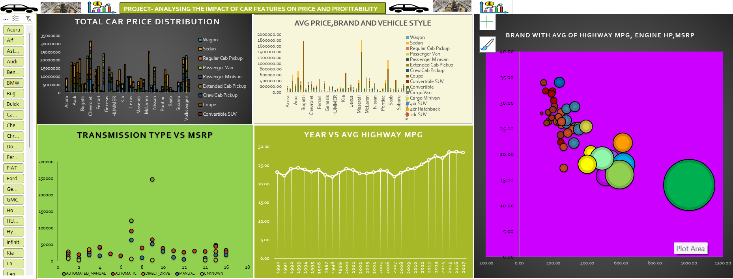

EXCEL REFER LINK: -

[CAR FEATURES BASED ON PRICE AND PROFIT.xlsx](CAR%20FEATURES%20BASED%20ON%20PRICE%20AND%20PROFIT.xlsx)

PPT VIDEO LINK: - <https://drive.google.com/file/d/1WTP54uuJNcD87VDCeSVm8BS6b1scq6So/view?usp=sharing>

